Practical 3A
AIM:- Demonstrate the use of Snort and Firewall Rules
Part1
a. Launch Oracle VirtualBox and change the CyberOps Workstation for Bridged mode, if necessary. Select Machine > Settings > Network. Under Attached To, select Bridged Adapter (or if you are using WiFi with a proxy, you may need NAT adapter) and click OK.
b. Launch the CyberOps Workstation VM, open a terminal and configure its network by executing the sh script.
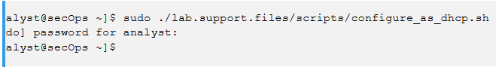
c. Use the ifconfig command to verify CyberOps Workstation VM now has an IP address on your local network. You can also test connectivity to a public webserver by pinging www.cisco.com. Use Ctrl+C to stop the pings.
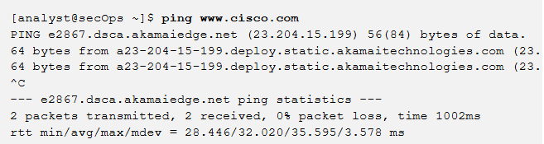
Part 2
Step 1: Real-Time IDS Log Monitoring
a. From the CyberOps Workstation VM, run the script to start mininet.
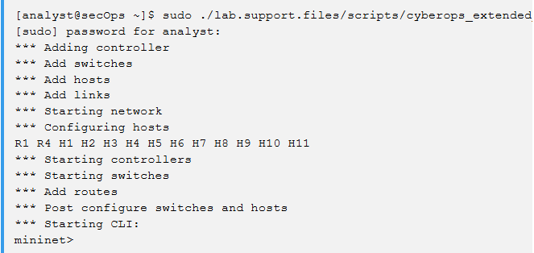
b. From the mininet prompt, open a shell on R1 using the command below:
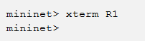
c. From R1’s shell, start the Linux-based IDS, Snort
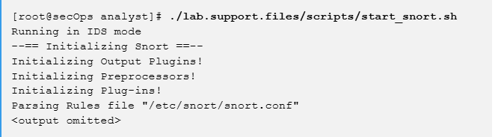
d. From the CyberOps Workstation VM mininet prompt, open shells for hosts H5 and H10.
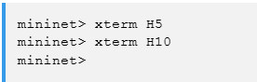
e. H10 will simulate a server on the Internet that is hosting malware. On H10, run the mal_server_start.sh script to start the server.
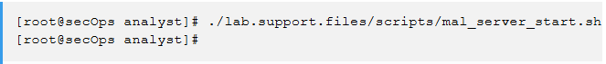
f. On H10, use netstat with the -tunpa options to verify that the web server is running. When used as shown below, netstat lists all ports currently assigned to services:
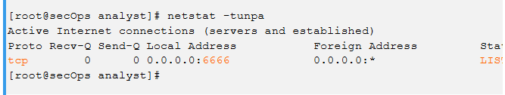
g. In the R1 terminal window, an instance of Snort is running. To enter more commands on R1, open another R1 terminal by entering the xterm R1 again in the CyberOps Workstation VM terminal window. You may also want to arrange the terminal windows so that you can see and interact with each device.
h. In the new R1 terminal tab, run the tail command with the -f option to monitor the /var/log/snort/alert file in real-time. This file is where snort is configured to record alerts.
i. From H5, use the wget command to download a file named Nimda.Amm.exe. Designed to download content via HTTP, wget is a great tool for downloading files from web servers directly from the command line.
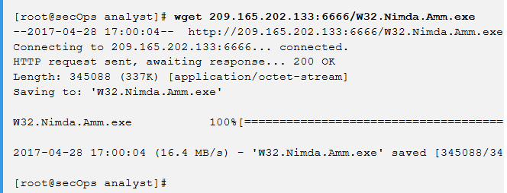
j. As the malicious file was transiting R1, the IDS, Snort, was able to inspect its payload. The payload matched at least one of the signatures configured in Snort and triggered an alert on the second R1 terminal window (the tab where tail -f is running). The alert entry is show below. Your timestamp will be different:
On H5, use the tcpdump command to capture the event and download the malware file again so you can capture the transaction. Issue the following command below start the packet capture
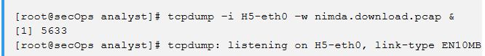
k. Press ENTER a few times to regain control of the shell while tcpdump runs in background.
l. Now that tcpdump is capturing packets, download the malware again. On H5, re-run the command or use the up arrow to recall it from the command history facility.
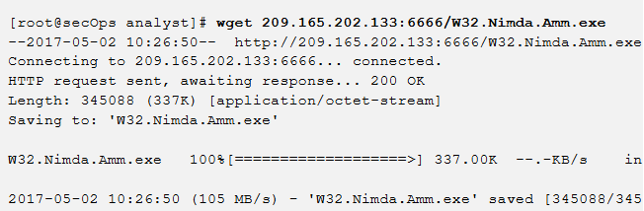

m. Stop the capture by bringing tcpdump to foreground with the fg Because tcpdump was the only process sent to background, there is no need to specify the PID. Stop the tcpdump process with Ctrl+C. The tcpdump process stops and displays a summary of the capture. The number of packets may be different for your capture.
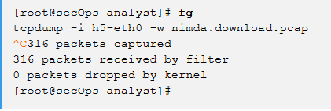
n. On H5, Use the ls command to verify the pcap file was in fact saved to disk and has size greater than zero:
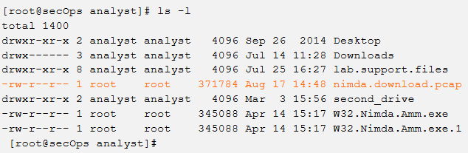
Step 2: Tuning Firewall Rules Based on IDS Alerts
- In the CyberOps Workstation VM, start a third R1 terminal window. 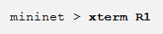
- In the new R1 terminal window, use the iptables command to list the chains and their rules currently in use:

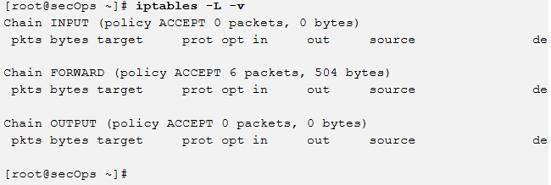
- Connections to the malicious server generate packets that must transverse the iptables firewall on R1. Packets traversing the firewall are handled by the FORWARD rule and therefore, that is the chain that will receive the blocking rule. To keep user computers from connecting to the malicious server identified in Step 1, add the following rule to the FORWARD chain on R1:
- Use the iptables command again to ensure the rule was added to the FORWARD chain. The CyberOps Workstation VM may take a few seconds to generate the output:
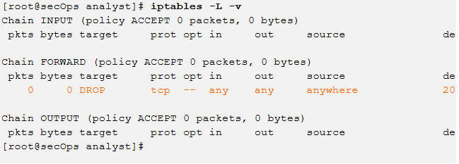
- On H5, try to download the file again:
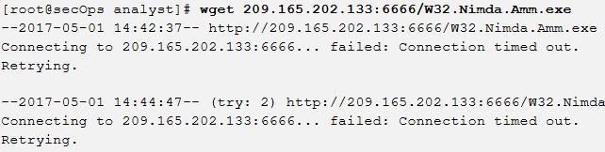
Enter Ctrl+C to cancel the download, if necessary.
Part 3: Terminate and Clear Mininet Process
a. Navigate to the terminal used to start Mininet. Terminate the Mininet by entering quit in the main CyberOps VM terminal window.
b. After quitting Mininet, clean up the processes started by Mininet. Enter the password cyberops when prompted.
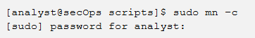

Practical 3 b
Aim - Extract an Executable from a PCAP (Instructor Version)
Part 1: Analyze Pre-Captured Logs and Traffic Captures
In Part 2, you will work with the nimda.download.pcap file. Captured in a previous lab, nimda.download.pcap contains the packets related to the download of the Nimda malware. Your version of the file, if you created it in the previous lab and did not reimport your CyberOps Workstation VM, is stored in the /home/analyst directory. However, a copy of that file is also stored in the CyberOps Workstation VM, under the /home/analyst/lab.support.files/pcaps directory so that you can complete this lab. For consistency of output, the lab will use the stored version in the pcaps directory.
While tcpdump can be used to analyze captured files, Wireshark’s graphical interface makes the task much easier. It is also important to note that tcpdump and Wireshark share the same file format for packet captures; therefore, PCAP files created by one tool can be opened by the other.
- Change directory to the support.files/pcaps folder, and get a listing of files using the ls –l command.
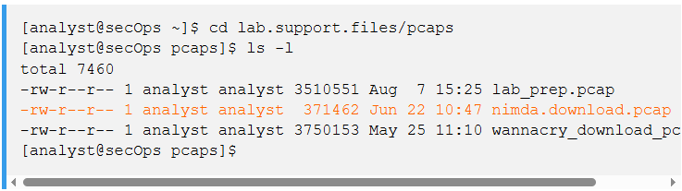
b. Issue the command below to open the download.pcap file in Wireshark.
- The download.pcap file contains the packet capture related to the malware download performed in a previous lab. The pcap contains all the packets sent and received while tcpdump was running. Select the fourth packet in the capture and expand the Hypertext Transfer Protocol to display as shown below
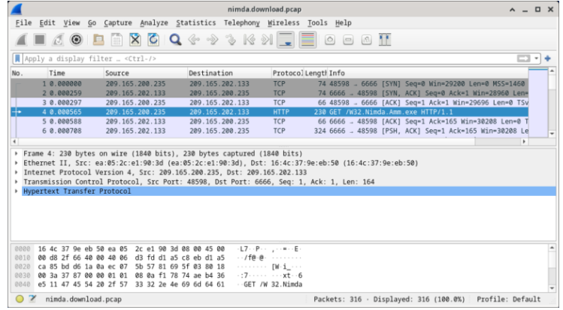
d. Packets one through three are the TCP handshake. The fourth packet shows the request for the malware file. Confirming what was already known, the request was done over HTTP, sent as a GET request.
e. Because HTTP runs over TCP, it is possible to use Wireshark’s Follow TCP Stream feature to rebuild the TCP transaction. Select the first TCP packet in the capture, a SYN packet. Right-click it and choose Follow > TCP Stream.
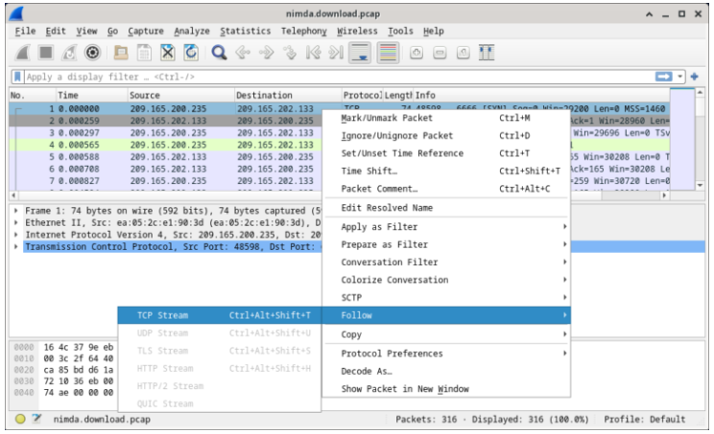
f. Wireshark displays another window containing the details for the entire selected TCP flow.
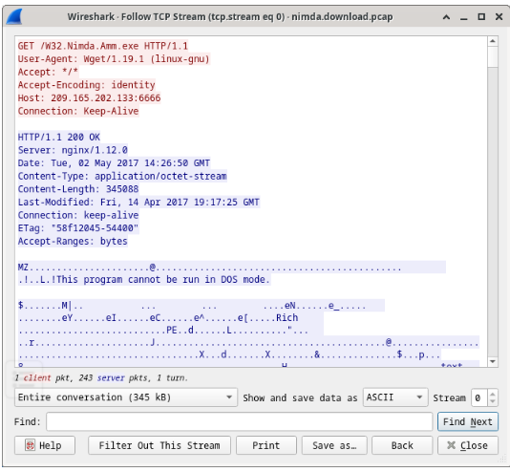
g. Click Close in the Follow TCP Stream window to return to the Wireshark nimda.download.pcap file.
Part 2: Extract Downloaded Files from PCAP
Because capture files contain all packets related to traffic, a PCAP of a download can be used to retrieve a previously downloaded file. Follow the steps below to use Wireshark to retrieve the Nimda malware.
a. In that fourth packet in the download.pcap file, notice that the HTTP GET request was generated from 209.165.200.235 to 209.165.202.133. The Info column also shows this is in fact the GET request for the file.
b. With the GET request packet selected, navigate to File > Export Objects > HTTP, from Wireshark’s menu.
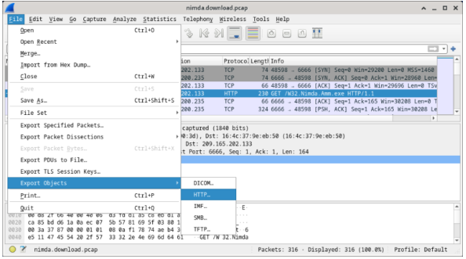
c.Wireshark will display all HTTP objects present in the TCP flow that contains the GET request. In this case, only the Nimda.Amm.exe file is present in the capture. It will take a few seconds before the file is displayed.
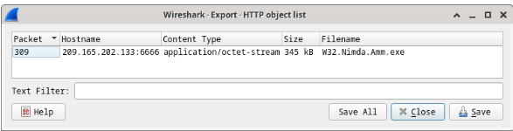
d. In the HTTP object list window, select the Nimda.Amm.exe file and click Save As at the bottom of the screen.
e. Click the left arrow until you see the Home Click Home and then click the analyst folder (not the analyst tab). Save the file there.
f. Return to your terminal window and ensure the file was saved. Change directory to the /home/analyst folder and list the files in the folder using the ls -l
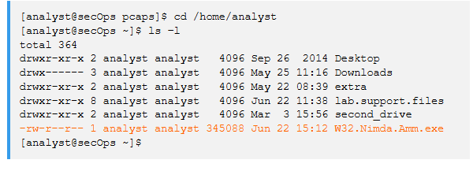
g. The file command gives information on the file type. Use the file command to learn a little more about the malware, as show below:
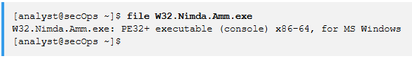
As seen above, W32.Nimda.Amm.exe is indeed a Windows executable file.

Practical 4a
Step 1: Start the virtual machine and log in.
Start the CyberOps Workstation VM. Use the following user credentials:
Username: analyst
Password: cyberops
Step 2: Open a terminal and start tcpdump.
a. Open a terminal application and enter the command ip address.

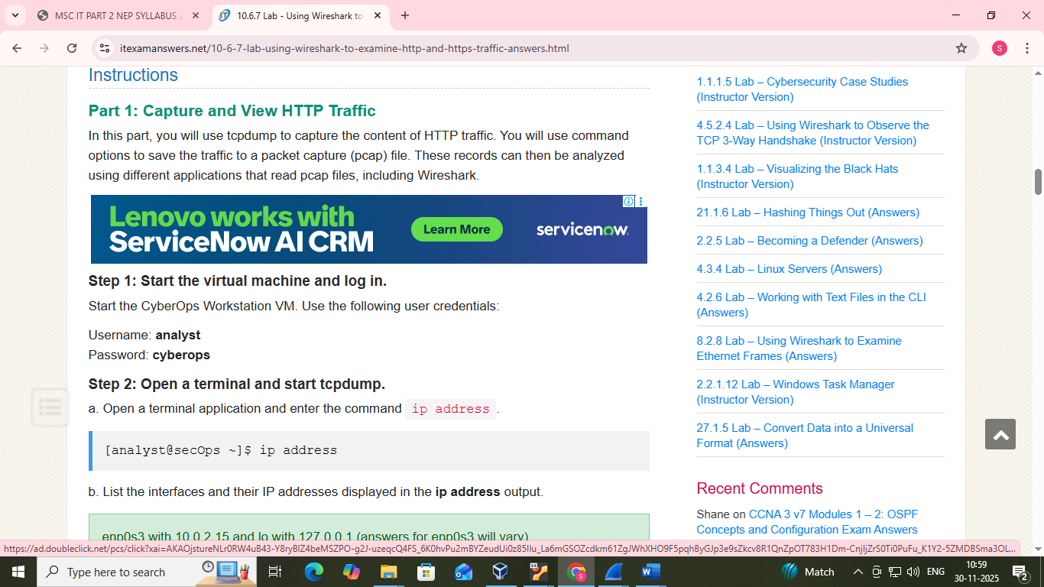

b. List the interfaces and their IP addresses displayed in the ip address output.
c. While in the terminal application, enter the command sudo tcpdump –i enp0s3 –s 0 –w httpdump.pcap. Enter the password cyberops for the user analyst when prompted.
[analyst@secOps ~]$ sudo tcpdump –i enp0s3 –s 0 –w httpdump.pcap
[sudo] password for analyst:
tcpdump: listening on enp0s3, link-type EN10MB (Ethernet), capture size 262144 bytes
e. Enter a username of Admin with a password of Admin and click Login.
f. Close the web browser.
g. Return to the terminal window where tcpdump is running. Enter CTRL+C to stop the packet capture.
Step 3: View the HTTP capture.
The tcpdump, executed in the previous step, printed the output to a file named httpdump.pcap. This file is located in the home directory for the user analyst.
a. Click the File Manager icon on the desktop and browse to the home folder for the user analyst. Double-click the httpdump.pcap file, in the Open With dialog box scroll down to Wireshark and then click Open.
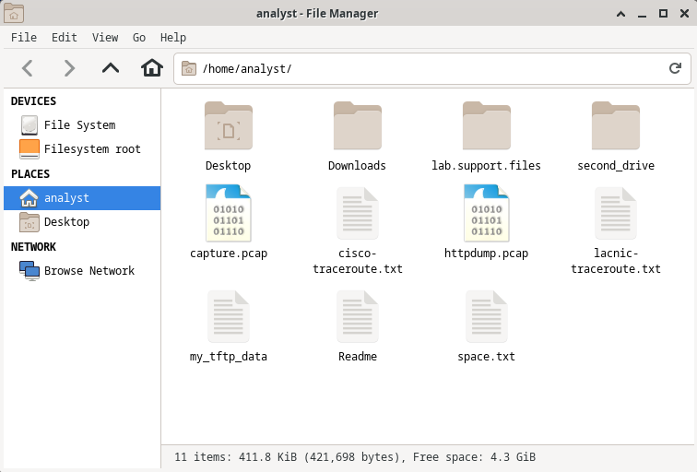
b. In the Wireshark application, filter for http and click Apply.
c. Browse through the different HTTP messages and select the POST message.
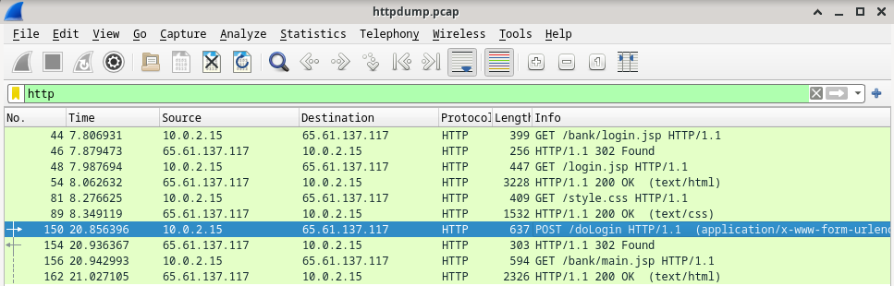
d. In the lower window, the message is displayed. Expand the HTML Form URL Encoded: application/x-www-form-urlencoded section.
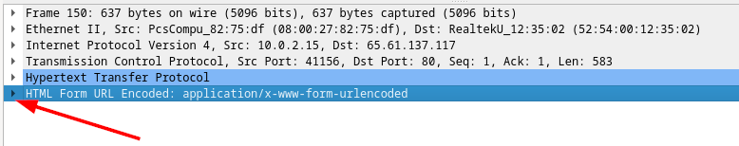
Instructor Note: Red font color or gray highlights indicate text that appears in the instructor copy only.
Objectives
- Part 1: Capture and view HTTP traffic
- Part 2: Capture and view HTTPS traffic
Background / Scenario
HyperText Transfer Protocol (HTTP) is an application layer protocol that presents data via a web browser. With HTTP, there is no safeguard for the exchanged data between two communicating devices.
With HTTPS, encryption is used via a mathematical algorithm. This algorithm hides the true meaning of the data that is being exchanged. This is done through the use of certificates that can be viewed later in this lab.
Regardless of HTTP or HTTPS, it is only recommended to exchange data with websites that you trust. Just because a site uses HTTPS does not mean it is a trustworthy site. Threat actors commonly use HTTPS to hide their activities.
In this lab, you will explore and capture HTTP and HTTPS traffic using Wireshark.
Required Resources
- CyberOps Workstation VM
- Internet connection
Instructions
Part 1: Capture and View HTTP Traffic
In this part, you will use tcpdump to capture the content of HTTP traffic. You will use command options to save the traffic to a packet capture (pcap) file. These records can then be analyzed using different applications that read pcap files, including Wireshark.
Step 1: Start the virtual machine and log in.
Start the CyberOps Workstation VM. Use the following user credentials:
Username: analyst
Password: cyberops
Step 2: Open a terminal and start tcpdump.
a. Open a terminal application and enter the command ip address.
[analyst@secOps ~]$ ip address
b. List the interfaces and their IP addresses displayed in the ip address output.
enp0s3 with 10.0.2.15 and lo with 127.0.0.1 (answers for enp0s3 will vary).
c. While in the terminal application, enter the command sudo tcpdump –i enp0s3 –s 0 –w httpdump.pcap. Enter the password cyberops for the user analyst when prompted.
[analyst@secOps ~]$ sudo tcpdump –i enp0s3 –s 0 –w httpdump.pcap
[sudo] password for analyst:
tcpdump: listening on enp0s3, link-type EN10MB (Ethernet), capture size 262144 bytes

d. Open a web browser from the launch bar within the CyberOps Workstation VM. Navigate to http://www.altoromutual.com/login.jsp
Because this website uses HTTP, the traffic is not encrypted. Click the Password field to see the warning pop up.
e. Enter a username of Admin with a password of Admin and click Login.
f. Close the web browser.
g. Return to the terminal window where tcpdump is running. Enter CTRL+C to stop the packet capture.
Step 3: View the HTTP capture.
The tcpdump, executed in the previous step, printed the output to a file named httpdump.pcap. This file is located in the home directory for the user analyst.
a. Click the File Manager icon on the desktop and browse to the home folder for the user analyst. Double-click the httpdump.pcap file, in the Open With dialog box scroll down to Wireshark and then click Open.

b. In the Wireshark application, filter for http and click Apply.
c. Browse through the different HTTP messages and select the POST message.

d. In the lower window, the message is displayed. Expand the HTML Form URL Encoded: application/x-www-form-urlencoded section.

What two pieces of information are displayed?
e. Close the Wireshark application.
Part 2: Capture and View HTTPS Traffic

Step 1: Start tcpdump within a terminal.
a. While in the terminal application, enter the command sudo tcpdump –i enp0s3 –s 0 –w httpsdump.pcap. Enter the password cyberops for the user analyst when prompted
[analyst@secOps ~]$ sudo tcpdump –i enp0s3 –s 0 –w httpsdump.pcap
[sudo] password for analyst:
tcpdump: listening on enp0s3, link-type EN10MB (Ethernet), capture size 262144 bytes
b. Open a web browser from the launch bar within the CyberOps Workstation VM. Navigate to www.netacad.com.
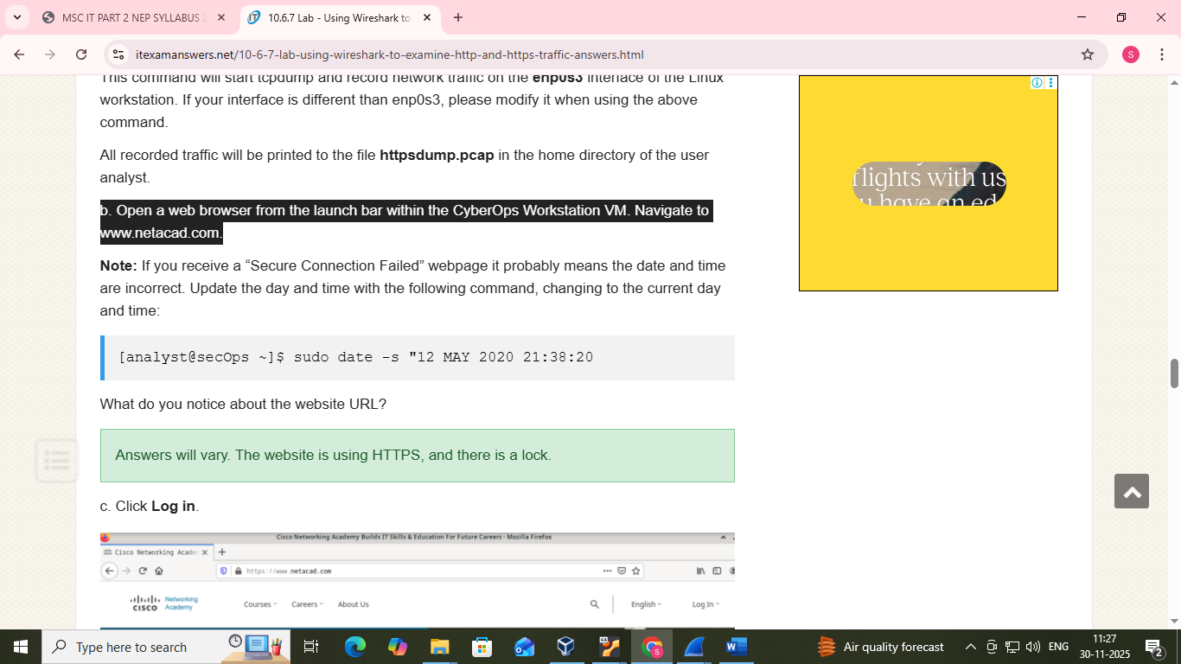
c. Click Log
d. Enter in your NetAcad username and password. Click Nexte. Close the web browser in the VM.
f. Return to the terminal window where tcpdump is running. Enter CTRL+C to stop the packet capture.
Step 2: View the HTTPS capture.
The tcpdump executed in Step 1 printed the output to a file named httpsdump.pcap. This file is located in the home directory for the user analyst.
- Click the Filesystem icon on the desktop and browse to the home folder for the user analyst. Open the httpsdump.pcap file
b. In the Wireshark application, expand the capture window vertically and then filter by HTTPS traffic via port 443.
Enter tcp.port==443 as a filter, and click Apply.

d. In the lower window, the message is displayed.

e. Completely expand the Secure Sockets Layer section.

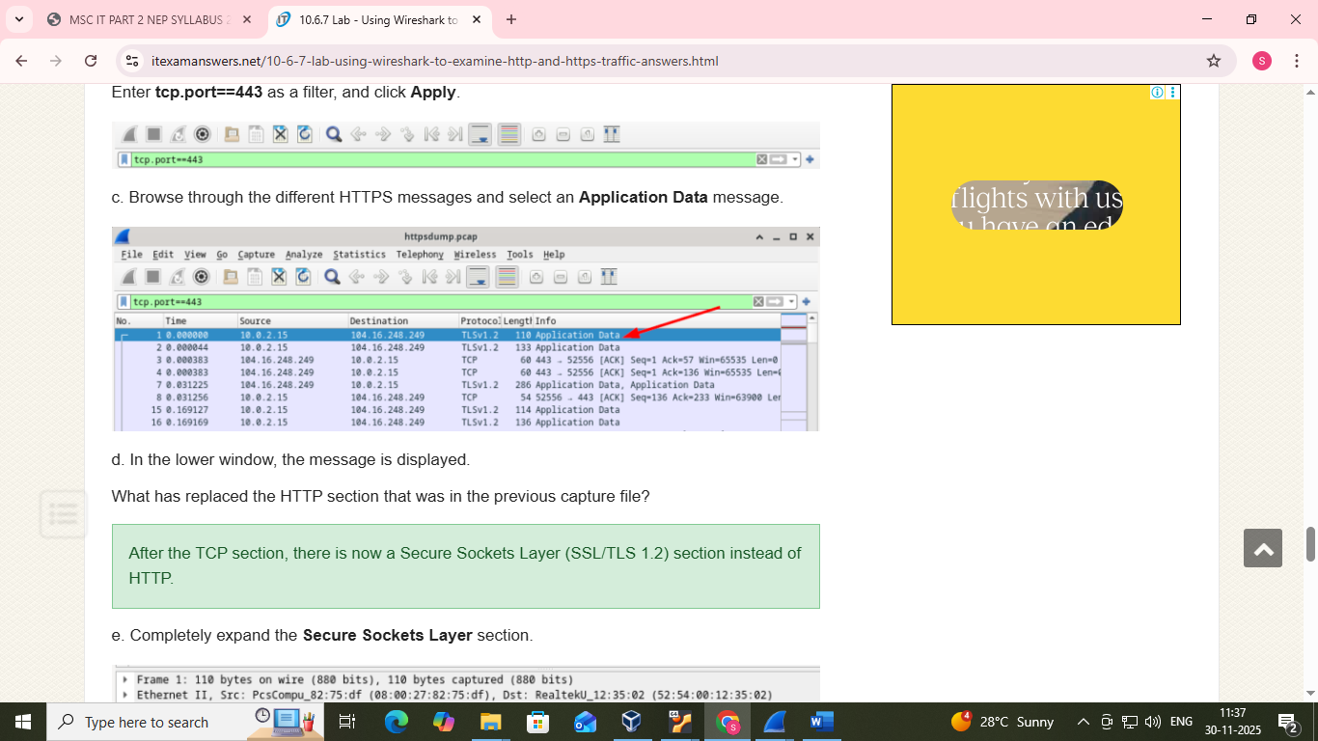
d. In the lower window, the message is displayed.
What has replaced the HTTP section that was in the previous capture file?
e. Completely expand the Secure Sockets Layer section.

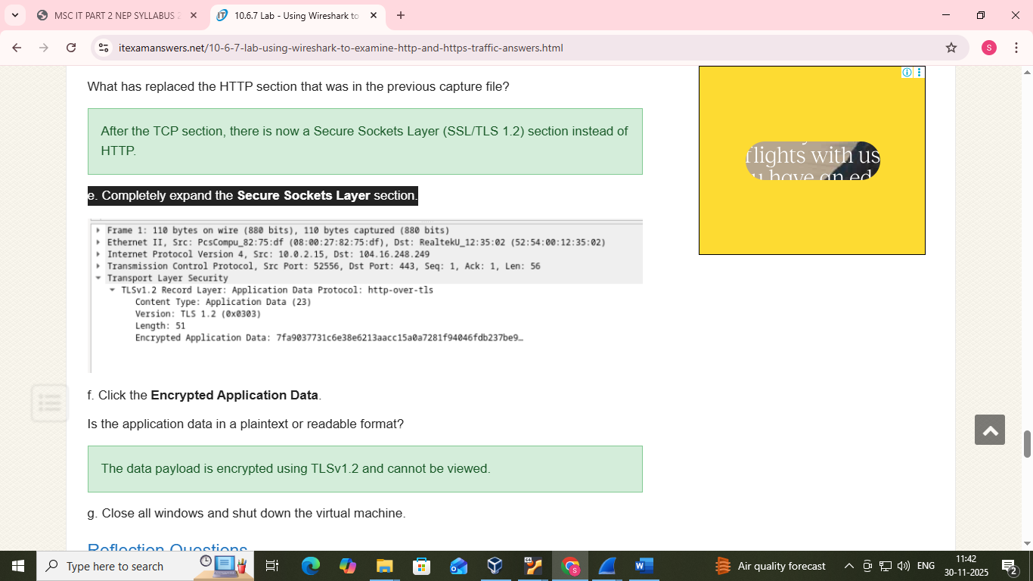
f. Click the Encrypted Application Data.
g. Close all windows and shut down the virtual machine.

Practical 5
Aim - Analyzing SQL Injection Attacks using Wireshark – ILM
Part 1: Open Wireshark and load the PCAP file.
Part 2: View the SQL Injection Attack.
Part 3: The SQL Injection Attack continues…
Part 4: The SQL Injection Attack provides system information.
Part 5: The SQL Injection Attack and Table Information
Part 6: The SQL Injection Attack Concludes
Part 1: Open Wireshark and load the PCAP file.
The Wireshark application can be opened using a variety of methods on a Linux workstation.
a. Start the CyberOps Workstation VM.
b. Click Applications > CyberOPS > Wireshark on the desktop and browse to the Wireshark application.
c. In the Wireshark application, click Open in the middle of the application under Files.
d. Browse through the /home/analyst/ directory and search for lab.support.files. In the lab.support.files directory and open the SQL_Lab.pcap file.
e. The PCAP file opens within Wireshark and displays the captured network traffic. This capture file extends over an 8-minute (441 second) period, the duration of this SQL injection attack.
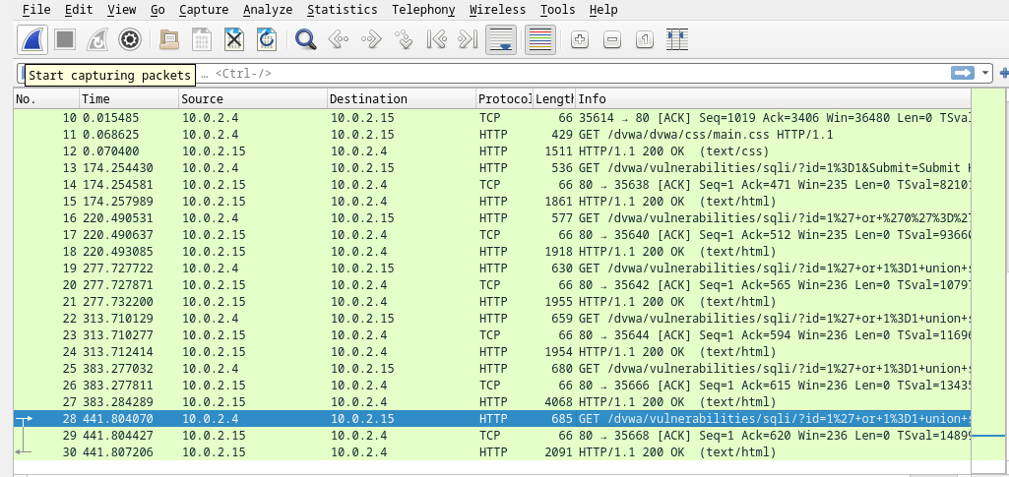
Part 2: View the SQL Injection Attack.
In this step, you will be viewing the beginning of an attack.
a. Within the Wireshark capture, right-click line 13 and select Follow > HTTP Stream. Line 13 was chosen because it is a GET HTTP request. This will be very helpful in following the data stream as the application layers sees it and leads up to the query testing for the SQL injection
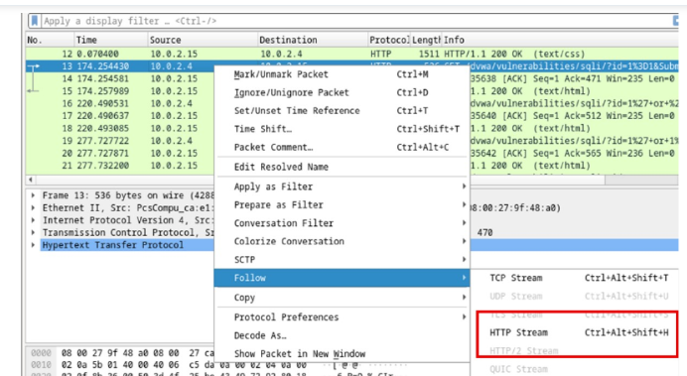
The source traffic is shown in red. The source has sent a GET request to host 10.0.2.15. In blue, the destination device is responding back to the source
In the Find field, enter 1=1. Click Find Next
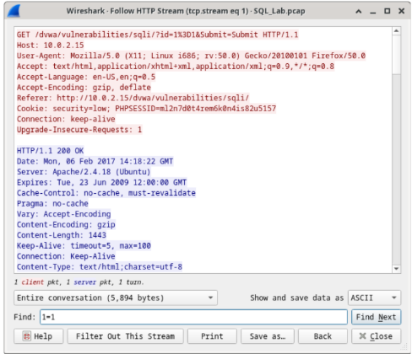
b. In the Find field, enter 1=1. Click Find Next.
c. The attacker has entered a query (1=1) into a UserID search box on the target 10.0.2.15 to see if the application is vulnerable to SQL injection. Instead of the application responding with a login failure message, it responded with a record from a database. The attacker has verified they can input an SQL command and the database will respond. The search string 1=1 creates an SQL statement that will be always true. In the example, it does not matter what is entered into the field, it will always be true
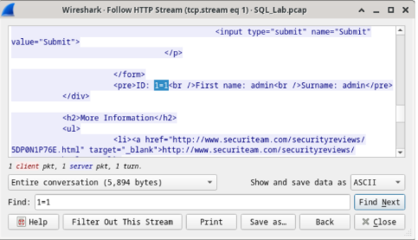
d. Close the Follow HTTP Stream window.
e. Click Clear display filter to display the entire Wireshark conversation.
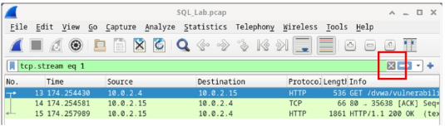
Part 3: The SQL Injection Attack continues...
In this step, you will be viewing the continuation of an attack.
a. Within the Wireshark capture, right-click line 19, and click Follow > HTTP Stream.
b. In the Find field, enter 1=1. Click Find Next.
c. The attacker has entered a query (1’ or 1=1 union select database(), user()#) into a UserID search box on the target 10.0.2.15. Instead of the application responding with a login failure message, it responded with the following information:
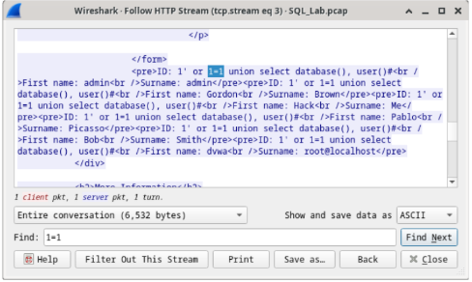
The database name is dvwa and the database user is root@localhost. There are also multiple user accounts being displayed.
d. Close the Follow HTTP Stream window.
e. Click Clear display filter to display the entire Wireshark conversation.
Part 4: The SQL Injection Attack provides system information.
The attacker continues and starts targeting more specific information.
a.Within the Wireshark capture, right-click line 22 and select Follow > HTTP Stream. In red, the source traffic is shown and is sending the GET request to host 10.0.2.15. In blue, the destination device is responding back to the source.
b. In the Find field, enter 1=1. Click Find Next.
c. The attacker has entered a query (1’ or 1=1 union select null, version ()#) into a UserID search box on the target 10.0.2.15 to locate the version identifier. Notice how the version identifier is at the end of the outputright before the </pre>.</div> closing HTML code.
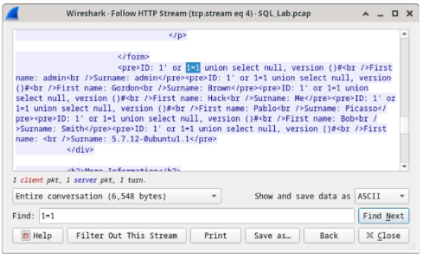
d. Close the Follow HTTP Stream window.
e. Click Clear display filter to display the entire Wireshark conversation.
Part 5: The SQL Injection Attack and Table Information.
The attacker knows that there is a large number of SQL tables that are full of information. The attacker attempts to find them.
a. Within the Wireshark capture, right-click on line 25 and select Follow > HTTP Stream. The source is shown in red. It has sent a GET request to host 10.0.2.15. In blue, the destination device is responding back to the source.
b. In the Find field, enter users. Click Find Next
c. The attacker has entered a query (1’or 1=1 union select null, table_name from
information_schema.tables#) into a UserID search box on the target 10.0.2.15 to view all the tables in the database. This provides a huge output of many tables, as the attacker specified “null” without any further specifications.
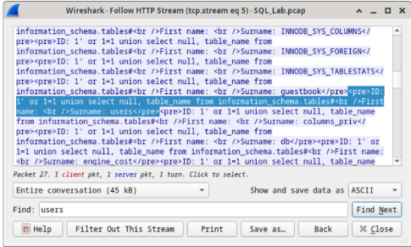
d. Close the Follow HTTP Stream window.
e. Click Clear display filter to display the entire Wireshark conversation
Part 6: The SQL Injection Attack Concludes.
The attack ends with the best prize of all; password hashes.
a. Within the Wireshark capture, right-click line 28 and select Follow > HTTP Stream. The source is shown in red. It has sent a GET request to host 10.0.2.15. In blue, the destination device is responding back to the source.
b. Click Find and type in 1=1. Search for this entry. When the text is located, click Cancel in the Find text search box The attacker has entered a query (1’or 1=1 union select user, password from users#) into a UserID search box on the target 10.0.2.15 to pull usernames and password hashes!
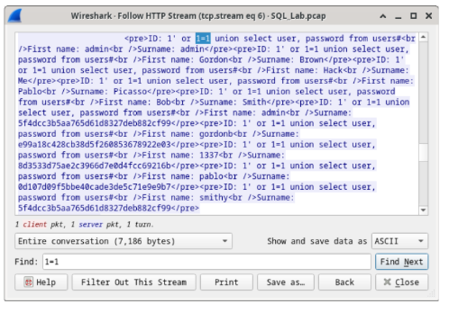
Which user has the password hash of 8d3533d75ae2c3966d7e0d4fcc69216b?
1337
c. Using a website such as https://crackstation.net/, copy the password hash into the password hash cracker and get cracking.
Question:
What is the plain-text password?
charley
d. Close the Follow HTTP Stream window. Close any open windows.
b. In the Find field, enter 1=1. Click Find Next.
- b. In the Find field, enter 1=1. Click Find Next.
- c. The attacker has entered a query (1’ or 1=1 union select null, version ()#) into a UserID search box on the
- target 10.0.2.15 to locate the version identifier. Notice how the version identifier is at the end of the output
- right before the </pre>.</div> closing HTML co
- b. In the Find field, enter 1=1. Click Find Next.
- c. The attacker has entered a query (1’ or 1=1 union select null, version ()#) into a UserID search box on the
- target 10.0.2.15 to locate the version identifier. Notice how the version identifier is at the end of the output
- right before the </pre>.</div> closing HTML code
- b. In the Find field, enter 1=1. Click Find Next.
- c. The attacker has entered a query (1’ or 1=1 union select null, version ()#) into a UserID search box on the
- target 10.0.2.15 to locate the version identifier. Notice how the version identifier is at the end of the output
- right before the </pre>.</div> closing HTML code
- b. In the Find field, enter 1=1. Click Find Next.
- c. The attacker has entered a query (1’ or 1=1 union select null, version ()#) into a UserID search box on the
- target 10.0.2.15 to locate the version identifier. Notice how the version identifier is at the end of the output
- right before the </pre>.</div> closing HTML code
- b. In the Find field, enter 1=1. Click Find Next.
- c. The attacker has entered a query (1’ or 1=1 union select null, version ()#) into a UserID search box on the
- target 10.0.2.15 to locate the version identifier. Notice how the version identifier is at the end of the output
- right before the </pre>.</div> closing HTML code

PRACTICAL 8
AIM:- Install and Run Splunk on Linux
STEPS:-
- After installing Ubuntu desktop, download Splunk Enterprise (.deb package) from their website. You will be required to create an account before downloading the installer.

- Link for downloading splunk in ubuntu:-
wget -O splunk-10.0.2-e2d18b4767e9-linux-amd64.deb https://download.splunk.com/products/splunk/releases/10.0.2/linux/splunk-10.0.2-e2d18b4767e9-linux-amd64.deb
- Open terminal and navigate to the Downloads folder.

- Check the location of the downloaded file of splunk.

- Install Splunk using the following command:
sudo dpkg -i splunk-10.0.2 -ee2d18b4767e9-linux-amd64.deb

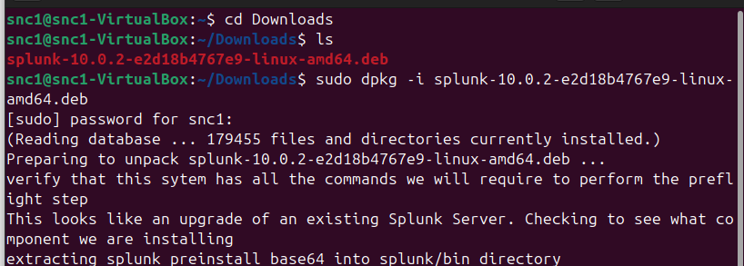

I received an error so I installed curl first and then I entered the Splunk installation command.

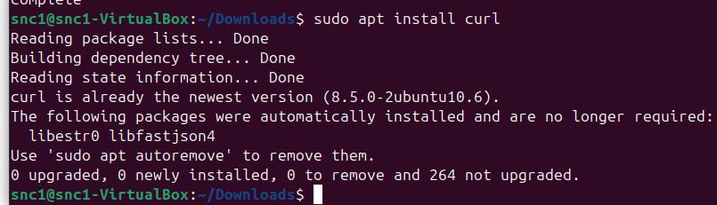

- We will now enable Splunk upon boot-up of the machine. Open up terminal and type:
sudo /opt/splunk/bin/splunk enable boot-start

- Scroll down and agree to the license.

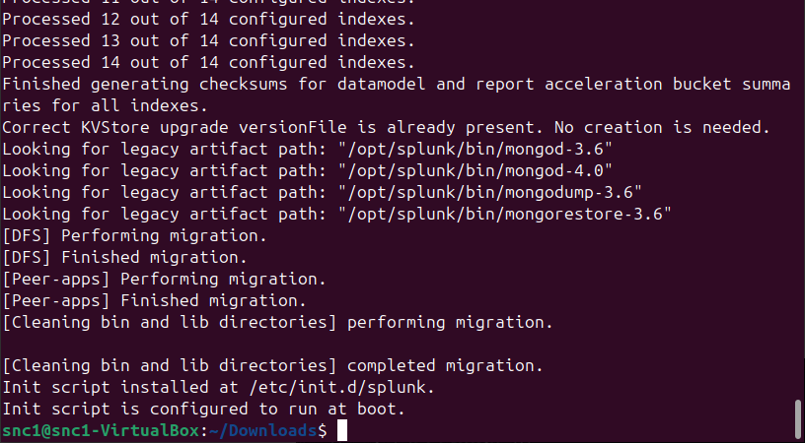

- Create an admin account and its corresponding password.
Username:-analyst
Password:-analyst@123
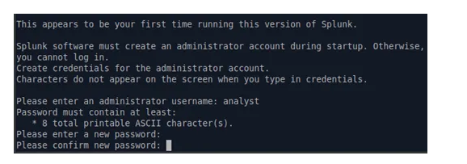

- Reboot the ubuntu.

- Once back on the main desktop, open up Firefox and go to localhost:8000. If Splunk was enabled upon boot-up, then we should get the Splunk login screen. Enter your Splunk admin credentials.
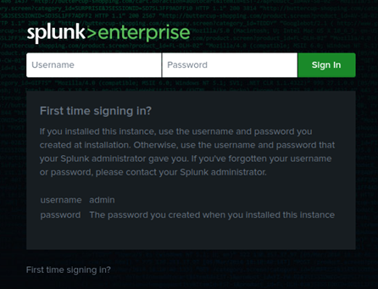
- After logging in, select Settings on the upper right hand side and go to Forwarding and receiving.
